**The Mechanisms of a Successful Web Business**

By Jamie Millman

Table of Contents

1. Introduction 3

2. Background research 3

2.1 The Brighton fuse 3

2.2 Brighton fuse 2: freelancer report 4

2.3 The lean start-up 5

3. Research 6

3.1 Competitors tools 6

3.2 Framework and toolkit analysis 8

3.3 Social media presence 14

3.4 Operation procedures 18

3.5 Registering my business 18

3.6 Joining an association 19

3.7 Insurance policies 20

3.8 Owning intellectual property 21

3.9 Site accessibility 21

4. Business plan 25

5. My company 35

5.1 Company name 35

5.2 Company logos 36

5.3 Company colour scheme 42

5.4 Company layout ideas 43

5.5 Company assets 50

5.6 Company fonts 52

6. Bibliography 55

**WRITE EVERYTHING IN THE PAST TENSE AND SLIGHTLY MORE FORMAL!**

**And remember to page break every page before completion. Add page numbers as well.**

**Go through and capitalise all proper names e.g. bootstrap, foundation etc.**

# 1. Introduction

# 2. Background research

This section covers the background research that I sourced from websites and literature. This information helped me gain a better understanding of the local digital sector and the business world in general.

## 2.1 The Brighton fuse

I began researching about the current state of the digital market in Brighton & Hove. From doing this I came across a project called The Brighton Fuse[1]. This is a project run by Wired Sussex[2], the University of Brighton[3], the University of Sussex[4] and the Council of Industry & Higher Education[5]. It is a research and development project that lasted two years. During these two years they analysed the growth of Brighton’s successful creative, digital and information technology (CDIT) cluster. The Brighton Fuse discovered a new business approach that when bringing together creativity and technology you can create a more successful business, these businesses are called ‘super fused’. The Brighton Fuse has empirical evidence to show that combining: the arts, humanities and design with creative, digital and IT skills enhances business creativity, innovation and growth.[6]

The Brighton Fuse also talked about the qualities that make a super fused individual in the Brighton CDIT cluster, those are: networking very frequently and placing great emphasis on creativity & business innovation. 65% of these super fused individuals combine creative design and technology with new business processes.[7]

From researching about The Brighton Fuse I can clearly see how combining creativity and technology would greatly improve the success of a business. I will be constantly exercising the traits that make up a super fused individual along with implementing creativity to every aspect of my business. By doing these I believe it will increase the chances of having a successful business.

## 2.2 Brighton fuse 2: freelancer report

After I finished researching about The Brighton Fuse, I noticed they recently released a second report. This report focused primarily on freelancers and how in creative, digital and IT sectors they fuel prosperity, success and growth. From this report it also mentions that freelancers enjoy good incomes, and are satisfied with their employment status.

The Brighton Fuse 2 report asks the question “To what extent does your work combine ideas from creative design and technology?” if you were to say “a lot” then you would be classed as super fused, “to some extent” you would be fused and “hardly at all” would be unfused. Statistics show that 46.7% of freelancers are super fused, compared to 34.7% in firms. One of the most interesting results of the Fuse project is that “the creative and digital firms in the cluster are strongly supported by a local community of freelancers. The average firm in the sample worked with 7 freelancers in the period 2011-2012, with 79% of firms working with at least one freelancer during the period.[8]

This evidence shows that firms in the Brighton CDIT cluster are working *with* super fused freelancers to help generate new innovative ideas. As a result generating more work for freelancers across Brighton & Hove.[9]

After researching about the Brighton Fuse 2 project it gave me confidence in creating a new sole trader business. Before reading this report I was unsure about the current market and what would be needed to create a successful business. Since reading both Brighton fuse reports I believe it has equipped me with the right theoretical tools to accomplish a successful business.

## 2.3 The lean start-up

The lean startup looks at a new approach coined by Eric Ries. It states that it will: build companies and launch products quicker, those products will be more in line with customer needs and it will reduces long development times and the amount of funding needed to launch a company. The way this is achieved is by a company building a minimum viable product, which is a version of the product with the bare minimum features. This is done to show users at an early stage for feedback. This eradicates the long hours creating a product without knowing exactly what the customer wants. Therefore when the product is ready to test, the customers might not want certain features or even the whole product. After they have shown the customers the MVP (minimum viable product) they will then hear the feedback and decide whether to: continue to build the product, tweak the existing product or pivot. Pivot is quite a common move used during a startup. A pivot is a “change in direction to test hypothesis about product, strategy or engine of growth”[10]. So this will be used when your product/business is not achieving what you initially thought it would. But through test results certain aspects have the potential to be very successful. So you change direction completely but stay grounded in what you have learnt.[11]

The new approach used in The Lean Startup was so informative I decided to adopt it and incorporate it into my business. This approach does not entirely relate to a website design and development business. However it made me grasp the idea of the MVP, allowing me to realise my ideas will not always be what a client wants. For example when creating the first draft of a client website I will monitor the time spent working on that draft. This will allow me to consciously reduce my time spend on it, to then get earlier feedback and find out what they would like changed. Harnessing this approach will save me a lot of time and in result money. As I will be optimising my time efficiently and not having to backtrack to make alterations at a later stage.

# 3. Research

## 3.1 Competitors tools

**Built by Buffalo**

I spoke to Dan Griffiths at Built by Buffalo[12] asking him what tools did his company use and what ones would he recommend for me to use. He mentioned for me to have a look at Foundation version 6[13], this version has really condensed down the amount of unnecessary code used to make it a lot more lightweight and better to use. I told him that I have used foundation before and wanted to get away from using a framework. He then went on to saying the tools his company uses. They use: SASS, CoffeeScript, Git (with Gitlab used for hosting their repos) and their own customised grid. They also use a patterns library that consists of “a few barebones projects, starter elements and design templates honed over the years.”  
  
From this conversion with Dan Griffiths It gave me an insight into what type of tools well-respected companies use in their day-to-day activities. I will analyse these set of tools to see if they will be right for me to use in my project.

**Net Natives**

**Clearleft**

I spoke to Charlotte Jackson at Clearleft about the tools their company use and what they would recommend for me to use. Clearleft “Work with top industry specialists to uncover fresh opportunities, develop your digital strategy, and bring new products and services to life.”[14] I was asked to sit in on a Clearleft tech development meeting to help me gain a better understanding of the tools commonly used in their company. From this meeting I gained a better understanding of what tools I should be focusing on, along with the benefits of using a patterns library.

Clearleft focus primarily on HTML, CSS and JavaScript in their day-to-day activities. However they believe it is good practise to have a basic understanding of most tools out there. Clearleft are very current and focus on keeping up to date with technologies and common web trends. Clearleft use pattern libraries[15] for a majority of clients they work with. This is something I am going to research into for the later stages of my company.

From my time spent at Clearleft I gained a large amount of knowledge about toolsets in the industry, and what ones would benefit my company. Although there are some tools I will be focusing on, I will be making a larger effort in trying to keep up to date with all technologies, both new and old, to gain a broader understanding of web technologies and trends in general.

**Ten4**

Ten4 are a “Web and app strategy, branding, design and development”[16] company located in London. I emailed them to find out what tools they used on a day-to-day basis to help me select the correct tools for the development of my project. I spoke to Andy Green at Ten4 and he talked about: the tools they use, their common practises and the reasoning behind using/doing these. They use their own framework titled ‘Ten4 Framework’[17]. This is where they store all of their templates and tools to use on each project. Andy mentioned that Ten4 use: Either Craft CMS[18] or Slim[19] to build their projects on, Gulp, their own built Sass library that includes a grid system and a folder they call ‘addons’ that they use as a dump for all of the useful code they will reuse in other projects (animated slideshows, Google maps etc.). I had never heard of Craft CMS or Slim, however after some research I do not believe I will be using these yet. I will focus on using a more easily accessible one like Wordpress. Once I have learnt to fully understand Wordpress I will then begin to research Craft CMS and Slim in more detail. The other tools Ten4 use (Gulp, Sass and a patterns library) I have previously researched and through communication with Andy has shown me professionals commonly use these tools; this has confirmed the use of them in the development stages of my project. Andy also mentioned how Ten4 are ‘quite anti-jQuery’ and focuses on using JavaScript libraries instead. The reason Ten4 do not use jQuery is for ‘performance, educational and to lesser extent compatibility reasons’. I have always preferred the use of JavaScript to jQuery, however I have been using jQuery in most projects I have undertaken due to the simplicity of it. From speaking to Andy I have come to the conclusion that I will try to eradicate jQuery from the languages used for each project. By doing this it will greatly improve my knowledge of JavaScript, which will improve website speed on desktop and mobile, reduce the size of files and allow for easier code management.

## 3.2 Framework and toolkit analysis

**Using a Bootstrap framework**

I have decided to use a bootstrap framework for the creation of my business website. The reason I have changed my mind and decided to use a framework is because the time I will be spending on this will be greatly reduced and the quality will stay the same if not improved due to the addition time I will have. I will be using the new Bootstrap 4 alpha framework[20] for my website. In Bootstrap you are able to choose versions of it. These versions allow you to select what features you would like to have in your framework. This can range from the full package right down to just keeping the grid feature. This gives me the freedom to choose how much of Bootstrap I would like to work with. I believe that choosing to use this framework will dramatically reduce the time spend on making my business website. As stated before this will free up a lot of time that I will be able to use improving various aspects of the project, whilst still keeping the quality of the website.

**Creating my own set of tools and pattern**

I have decided to change from using a bootstrap framework to creating my own set of tools for the development of my project. The reason I have decided to change my idea is because not only would it give me complete freedom during the development. It will also save me a large amount of time during the initial setup of each project. With Bootstrap I would need to remove the pre-implemented styles during the creation of each project. This would have to be done to stop client websites looking very similar. This would be a time consuming task. With the tools I will be creating it will make this process a lot faster and easier to manage. I planned to use a condensed version of bootstrap so I could eradicate the need to free code responsive navigation, a gridding system and various other aspects on each project. Instead I am going to create a patterns library that will hold all of my code previously used on other projects. This will solve the problem of unnecessarily free coding sections on every project and it will be done without the use of a large framework.

Many website design and development companies choose to use their own set of toolkit libraries to have as a standard mark-up when creating websites. These toolkits provide valuable assets that will speed up, improve and make the development process faster. These toolkits include assets like: a grid system, the text editor used (this is where you would write all of your code) like sublime text[21] or brackets[22], various libraries like Mordernizr(helps you manage and support old browsers with JavaScript and css)[23] and Normalize(makes a browser render all elements more consistently through styles)[24], CSS pre-processers(A scripting language that extends CSS and gets compiled into regular CSS syntax) like SASS[25] and LESS[26], JavaScript pre-processers such as CoffeeScript[27] and version control systems(used for tracking and controlling project files) like Git[28] and Subversion[29].

Before creating my personal toolkit library I thought it would be a good idea to get some expert advice on what tools current website design and development companies are using and what ones they would advise to use. The companies I emailed were: Built by Buffalo, Net Natives, Clearleft and Ten4.

**Sublime Text**

Sublime Text is a one of the most popular text editors used by front-end developers. It is a paid text editor, however you can use it for free if you are not bothered by occasionally being prompted with adverts. A text editor is a computer program that allows users to input their chosen coded language into. For front-end development (the development of a website or web application) the user would then host these documents online so they can be accessed over the Internet. A majority of developers would choose a text editor due to preference, however the top text editors (Sublime Text, atom, brackets) have catered their design and functionality to what a developer would find user friendly. The aspects that a developer would usually look for in text editors are: good colour coding, good window management, good extensibility, easily implementable plugins, easily accessible user interface and sometimes the use of autocomplete for various programming languages. Sublime Text implements most of these points very well and I personally believe the user experience is very intuitive and pleasing to use.

**Git**

Git is a version control system (VCS) that allows you to remotely save changes made to your work. You can then push those changes online. Once those changes have been pushed online they are forever saved online as the updated version. Github is the online repo used to host my files. It shows you the bits of code that you have removed and the new code added to replace it. This allows you to monitor your work and see when certain changes were made. I have never used Git until this project. It is an extremely useful tool that I will be forever using on every development task I undertake.

**Sass**

Sass (Syntactically Awesome Style Sheets) is a scripting language that gets interpreted into CSS once it has been processed. This is called a pre-processor. “Sass is the most mature, stable, and powerful professional grade CSS extension language in the world.”[30] In a poll done in 2012 studies showed that more people preferred using Less than Sass[31]. However since that poll SASS has become a lot more popular due to updates and changes. HTML, CSS and JavaScript frameworks such as Foundation, Skeleton and Bootstrap all focus a lot more on Sass now. Foundation has been Sass from the beginning, Skeleton is both Less and Sass and Bootstrap(the most popular framework) has recently switched from Less to Sass. This shows Sass is beginning to take over as the leading pre-processor. Again, there is a large aspect of personal preference involved in selecting the right pre-processor. After trying both Less and Sass, I found myself enjoying the experience of Sass a lot more.

**Gulp**

Gulp is a build tool (or task runner) that allows you to automate various tasks that would originally be manual. Some of these tasks include: compiling Sass, compressing your images, minify you CSS, minify your JavaScript and live reloads of a browser page. You would define these tasks in a gulpfile.js file and run them through the terminal. I originally looked into Gulp primarily for the Sass compile task. After some research I found out that not only would this be the best for compiling Sass, but also it would give me the freedom to add in multiple beneficial tasks, the ones stated above and more. The initial learning curve of using the terminal and calling from the gulpfile.js, proved to be quite challenging. These are two aspects I have never used for front-end development before. Once I began to understand how to use Gulp it became apparent just how much time and effort I would be saving during the development stages of my project. [32]

**Custom Grid**

Creating a custom grid will give me complete freedom to make it as responsive as I like and define how many columns and rows I want as a maximum and minimum for each web page. The usual way to access a pre-defined grid system is by using frameworks like: Bootstrap, Foundation, Skeleton and many more. However you are also able to download stand-alone grid systems such as: 960 Grid System[33], Fluidable[34] and One % Css Grid[35]. I was originally going to use the latter of the two examples I just explained, the stand-alone grid system. But then instead I decided to create my own grid system from scratch. The benefits from creating my own grid will be: the file size will be dramatically reduced, I have complete freedom in choosing how responsive it will be, I will make the terminology simplistic to understand for all and I will have the potential to improve my grid at any given stage.

When creating my personalised grid I used a tutorial by Jan Drewniak[36] to get a basic understanding of how a grid system works. After implementing this basic grid I then began to adapt and improve the grid system to be more catered towards my development preferences. The grid system will continue to evolve until it fully satisfies my development needs.

**CoffeeScript**

CoffeeScript is a pre-processed language that compiles into JavaScript. CoffeeScript, like Sass for CSS, changes the syntax needed to write correct code. This is the main reason I have chosen **not** to use CoffeeScript for my final project. The reason for this is because I want to be able to use JavaScript more fluently before learning another language that will focus on using different syntax to make it easier to output into JavaScript. However I will look into learning CoffeeScript in my own time after this project has been completed because from what I have researched it showed me that CoffeeScript is an exceptional language to learn if you want your code to be more fluid and readable.[37]

**Normalize.css vs CSS reset**

Normalize and traditional CSS resets have been introduced to reduce the amount of inconsistencies between browser’s for elements like: line height, margins, font sizes etc. CSS resets was around a long time before normalize, however since the release of normalize.css many frameworks, toolkits and sites such as: Twitter Bootstrap, HTML5 Boilerplate, Gov.uk, CSS Tricks and many more use it.[38]

There are many aspects that differentiate normalize from CSS resets. The main being that CSS resets aim to *remove* all built in browser styling’s and normalize aims to make all built in browser styling’s *consistent*. This allows some useful default browser styles to remain, meaning you don’t have to re-declare styles for common typography elements with normalize. Other benefits for normalize include: fixing desktop and mobile browser bugs that CSS resets cannot (such as SVG overflow in IE9), being modular to allow easier viewing and editing, improved targeting styles to reduce cluttered debugging tools and it has extensive documentation to allow users to fully understand each line of code.[39]

After researching about both normalize and CSS reset, I decided to choose normalize.css as my cross platform consistency style sheet. I found the sheer amount of documentation for normalize extremely appealing. This is because it allowed me to fully understand what I was implementing into my development. I also believed it was more efficient to have the default browser styles made consistent as apposed to removing them, therefor resulting in me not having to re-declare basic styles.

**Modernizr.js vs Feature.js**

Modernizr.js and feature.js are browser feature detection libraries, that run tests as your web page loads to detect what browser the user is running and find out what HTML, CSS and JavaScript features will work in it. This is done to allow every user to have a similar experience when viewing your website. If a user is running an old browser that does not support some of the content on your website, then you can implement these JavaScript libraries into your code to allow your website to cater a similar experience towards those users.

When choosing between the two I found that modernizr.js had a lot more documentation because it has been around a lot longer than feature.js, and was therefor easier to find tutorials to implement it correctly. However feature.js is an extremely lightweight, plain JavaScript version of modernizr.js with a file size of 1kb. Overall feature.js focuses on delivering a faster service. For example it automatically initializes itself during the page load and does not run tests without the developers permission. This makes the performance very fast.

Although modernizr.js has more documentation to help understand the script better. Feature.js is a newer, faster and cleaner browser feature detection library that is simple to understand and has enough information on the website to easily make your detections quite advanced. This is why I have chosen to use Feature.js for my final project.

**JavaScript vs jQuery**

When looking at the tools I was using for the development of my project, a question arose when particularly looking into CoffeeScript. That question was whether to write in JavaScript or jQuery for the development of my project. I have been using both infrequently for two years now. In previous projects I tended to use jQuery more than pure JavaScript. This is because I believed it was easier to use and you could achieve a similar result with less lines of code. I decided to do some research to find out what other developers thought about JavaScript and jQuery. When researching online I found lots of different threads and articles explaining the positives and negatives for both. Overall I found that developers preferred to use JavaScript to jQuery for larger projects. One of the main reasons for this is because of it’s better performance. This is because of increased loading speed, reduced file size and better optimised performance. jQuery was not specifically designed with mobile in mind so certain functions (like the click function) cause large delays. One of the main benefits of jQuery is the reduced development time and how it’s friendly towards beginners. The reason for this is because it is harder to make mistakes and the API and numerous plugins are easier to use. jQuery is a JavaScript library that makes the developer write slightly different syntax to pure JavaScript. Developers that do not completely understand JavaScript would find it hard to actually learn how the language worked if primarily using jQuery. I found this to be very important when selecting between the two. If I used pure JavaScript I would be improving my understanding of the language that would be needed if I wanted to write more advanced code. If focusing on jQuery I would improve my jQuery skills but I would not be improving my knowledge of JavaScript, the language jQuery is based on. This would allow me to progress to a certain point before inevitably having to learn more about JavaScript.[40]

I also communicated with various web design and development companies and all of them focus on using JavaScript over jQuery. This may have something to do with them generally working on larger projects. However when speaking to Andy from Ten4 he said the following.

“From experience teaching placement students here, I've found that blind use of jQuery unsurprisingly gives no real understanding of Javascript programming as a whole. By 'banning' jQuery, we cultivate better problem-solving developers, who are always surprised how simple and flexible the 'proper' way actually is.

This reinforced the conclusion I came to from my research that I should primarily focus on JavaScript until I have a better understanding of the language. I will consider learning about jQuery in more detail later on in my career. However the main benefit of learning it would be for improved speed during development, so as long as I ensure my knowledge, skill and speed in pure JavaScript is very high I don’t see there being a reason to use it in the future.

**Patterns Library**

I have been researching pattern libraries and seeing if it would be beneficial for me to use when handing over deliverables to clients. After speaking to the development team at Clearleft I gained a better understanding of why using a pattern library would be beneficial for certain projects. A pattern library allows you to break up your code into modules. This allows you to isolate sections of code to make it easier for clients to implement that specific code into their existing website, e.g. footer, sign-up form, navigation etc. This is quite a specific way to show a client your deliverables. It would mainly be used when a client has a tech team that works on websites, this is because it involves the client receiving the code and implementing it into their existing website. I am going to use a pattern library called Pattern Lab[41]. This is a free to use pattern library that Charlotte Jackson from Clearleft recommended me to use. I will use this pattern library to gain a better understanding of how it works. Then I will be able to use it to improve the handover of deliverables once I gain the right client.

**CREATE A TABLE TO SHOW WHAT TOOLS I HAVE USED AND A SMALL SENTENSE ABOUT EACH TOOL. THIS WILL BE USED TO HELP THE USER HAVE A VISUAL REPRESENTATION OF THE TOOLS USED.**

## 3.3 Social media presence

**Facebook**

I will be creating a professional Facebook account for my company. Facebook is currently the most popular social media website with an estimate of 900 million unique monthly visitors.[42] Although Facebook isn’t primarily used for professional businesses, if the page is done correctly it can generate a lot of views and potentially leads. Nutella is a great example of a well-made Facebook page. Nutella regularly post: competitions, fun facts, adverts, fans pictures and recipes. By doing this it keeps your users/fans interested in your page whilst also marketing to them. Creating interesting and intuitive posts is very important. If a user considers a post good enough to share, then that post will be displayed to that users entire friends list. In result spreading their marketing posts across the whole of Facebook. Photo competitions are a great way to get users to interact with your page. The user would upload a relevant image and tag the company. This would result in images of your products circulating Facebook, potentially getting new users to view your page and generating relevant conversation about your company.[43]

When creating my Facebook page I will be looking to regularly update it with: fun facts, tutorials, informative posts and progression of the business. By doing this correctly I will gain a large following on the most popular social media website. This will be easily transferable across social media platforms allowing me to obtain backlinks and multi-platform followers.

**Twitter**

I will be creating a professional Twitter page to market my business. Twitter is second on the leader board of most popular social media websites with an estimated 310 million unique monthly visitors.[44] Twitter is a good balance between professional and fun. A very important way to successfully market to a large audience is to regularly post (tweet) informative, humorous or interesting information that is easily accessible for the general public to interact with. By getting as many users to interact with your posts, it will result in your information getting re-posted (re-tweeted) so more users will be able to view it. I came across an article titled “9 Small Business Twitter Marketing Examples to Study”.[45] In this article it listed nine points to focus on when creating a professional business twitter account for a small business. Those points were:

1. Use twitter to stand out.
2. Keep your followers interested.
3. Stick with it.
4. Provide a balance of work and fun.
5. Keep your mobile users in mind.
6. Listen to your customers.
7. Promote hard to find products.
8. Connect with people who need what you have to offer.
9. Use twitter for lead generation.

I believe this list really shows you what is needed to successfully market your business on twitter. Some of the key points from this list are more important for specific projects, the ones I believe to be most important for my project are: Use twitter to stand out, Keep your followers interested, Provide a balance of work and fun and Listen to your customers.

Using twitter to stand out is an obvious but very important point. Because there are so many companies/users on twitter you have to try new things to stand out and get people interested in your company. This point is very important for my business because I am going to need to try new things to reach my target audience to keep them interested enough to continue to follow my company page.

Keeping your followers interested is also a very important point. It ties in quite a lot with the previous point, Using twitter to stand out, because to keep users interested you might need to stand out and the reason to stand out might be to keep your followers interested. I believe this point is the most important on the list. If users begin to lose interest with my company page then that will result in losing followers and potential customers, which is the main reason to market on Twitter, to gain customers.

Providing a balance of work and fun will be very important for my specific business Twitter page. The reason it will be so important for my business specifically is because my target audience is going to be so varied. With other companies like software companies and computer game companies they usually have a narrower more focused target audience that share likes and dislikes, this would make it easier to market to. So by providing a balance of work and fun it will allow me to engage with a larger selection of users.

Listening to your customers for any business is very important. If you can show your customer service is quick and painless, this will definitely keep users interested in your page. Even though customer service will not commonly be done over Twitter for my kind of business, if users ask questions about videos, competitions and articles posted then responding to those quickly will show how active you are on your account and will entice users to ask more questions, therefor increasing the interaction on your page.

All of the points on the list are important for any business, but I felt the ones stated above I should focus on to ensure my company’s interactivity is as much as possible. This will prevent users from un-following the account.

**LinkedIn**

I will be creating a LinkedIn page to market my company. LinkedIn is third on the leader board of most popular social media websites with an estimated 255 million unique monthly users. [46] LinkedIn is the most popular professional social media website. It primarily focuses on professional work unlike Facebook and Twitter. LinkedIn will be a great platform to network with professionals through posting informative or humorous articles, videos and images. LinkedIn allows you to edit your profile to display: information about your company, the skills your company have, the field you specialise in and much more. This allows users to see what your company does and potentially gain a lead from it. I believe LinkedIn is a necessity for my business. It will not only potentially get me clients, but also allow me to network with other professionals and talk about common trends, new developments and other important factors in my companies sector. This will result in me gaining important contacts for future developments of my business.

**YouTube**

Creating a YouTube channel for my business will increase my reach to users by having another platform to market on. I will focus on uploading tutorials on my channel for informative tasks and tips for starting out with website design and development. These tutorials will stretch from coding best practise to marketing your business correctly. By creating this YouTube channel I will be improving my SEO with multiple backlinks to my website and other social media sites. It will also gain me a larger user fan base through them learning new information and my company being connected to their source of learning.

Those are the four social media websites I will be marketing on. Facebook, Twitter, LinkedIn and YouTube. Each website has their benefits over the other so by marketing on all I believe it will cover a large amount of the social media scene. In result getting my company acknowledged across many platforms through informative and humorous content.

**Business model canvas**

I have decided against creating a business model canvas at this stage in the project. The reason for this is because I didn’t think my business would benefit from this task. The business model canvas works as a step-by-step business planner that you are able to add to when you feel necessary. It focuses on sections like: customer relationships, revenue streams, customer segments and value propositions.[47] These specific sections I would be unable to currently fill in. I may consider creating one later on in the process but at this stage I am not going to.

## 3.4 Operation procedures

**Potentially have a short introduction to this section where I can talk about Bee Purple and Sam as part of my research and learning process.**

**Contracts**

READ THE EMAIL FROM SAM AND TRY AND CREATE A CONTRACT!!!

**Quotes**

A quote is given to the client after the payment package and general website description has been discussed. I then give the client a breakdown of hourly rate followed by an estimated completion time (in hours). The price quote is then given to the client through this process.

**Payment terms**

I have decided to create payment packages to allow clients to choose the level work/money put into their website. There will be 3 packages ranging from a 1 that would be a single page website to a 3 that will be a fully bespoke design. The biggest benefit from doing price packages is to allow the client to know the amount of money needed to pay for the amount of work they are wanting. This also prevents the client bartering with you or being unhappy with the result for the amount of money they paid. By doing the payment packages it cuts out any confusion between the customer and myself with regards to money and the amount of work. It also allows me to create fully bespoke websites and charge the correct amount. Whilst also letting the client visually see what additional features they will gain from paying more for this package by comparing to the other ones

Because I decided to add payment packages it allows the client to get a general price range for the package they decide to choose. Each price package has an estimated lowest and highest rate; their constructed quote will fit between those estimates. The payment is done in two instalments; half up front for safety precautions and half once the project is completed. This will be invoiced to the client once the: price, time and project scope have been arranged.

**Invoice**

**ATTACH AN INVOICE BECAUSE IT WILL BE A PRINTED COPY SO CAN’T ATTACH!!**

## 3.5 Registering my business

**Sole trader vs Limited company**

When setting up a business it is important to register your company as one of the following: a sole trader, limited company or business partnership. Due to the type of company I have created, the two I focused on were sole trader and limited company.

A sole trader means an individual runs the company and that person is self-employed. Having a sole trader company does not mean you have to work alone, you are able to hire as much staff as you want. Setting up a sole trader company is the quickest and easiest out of all of the options. Along with keeping records of your income and outgoings, the only documentation you need to deal with is sending a yearly self assessed tax return. Because you are solely responsible for the company, in the unlikely event that a client was to sue you, you would be held personally liable to settle that claim.[48]

A limited company can be run by multiple individuals, and the company itself is responsible in it’s own right for everything it does. There are a lot more conditions that need to be met before you are able to set up as a limited company, along with more documentation, such as: having at least one shareholder and one director, an address for the company, producing a statement of capital, producing an article of association and producing a memorandum of association. Certain documents are recommended to be completed by a professional accountant, meaning an annual spend from the company’s budget. Any profit that is made is owned by the company and then distributed accordingly (after tax). Because the money is owned by the company this means the individuals have more personal protection in terms of financial liability, meaning if your were to get sued as a company then the company’s assets would be liable and not your personal belongings.[49]

Due to the nature of my company I felt the likeliness of getting sued was very minimal. On top of this I believe the documentation and potential hiring of an accountant was unnecessary for this stage of my business. This is why I chose to set up my business as a sole trader company. Since doing this research gained a greater understanding about sole trader and limited companies. Because of this I estimated in the next 2-3 years I would be changing my business from a sole trader to a limited company.

## 3.6 Joining an association

**Wired Sussex**

Wired Sussex is paid membership organisation located in Brighton to help digital, media and technology companies to create, innovate and grow. There are many reasons why paying to join Wired Sussex is a beneficial investment. Being part of an organisation with over 2000 companies that are relevant to your sector, allows you to easily network with potential partners/clients to help your business grow. They provide a projects board that informs you of any work relevant to your company that may have become available. This project board also advertises individuals that you could potentially recruit to improve your business.[50]

Joining Wired Sussex I believe was a fantastic investment to help my business grow faster. By being a member it not only gives me a greater opportunity to improve my business and gain work. It also gives me a platform to network with other professionals to keep up to date with current affairs and new developments in the digital world.

## 3.7 Insurance policies

**Professional indemnity insurance**

Professional indemnity insurance (PI insurance) is a type of liability cover designed to protect an individual or business against claims made by clients for loss or damage due to negligent advice or services.[51] PI insurance will help my company in the unlikeliness of the client being unsatisfied with the product received and asking for compensation. I will not be using this insurance until my company grows in size and will have multiple projects in production at one time. This is because multiple employees will be working on projects simultaneously, so I cannot ensure mistakes are not made on every project. This insurance will cover the expenses if the customer’s needs are not met and they decide to ask for compensation.

**Property insurance**

Property insurance is a policy that allows reimbursement to the owner if their equipment is affected by: fire, water, theft, loss, accidental damage or a natural disaster.[52] By having property insurance it will reduce the impact my company will take financially from loss of equipment. It will also help cover compensation for clients if their information/work is lost. I will be looking into using property insurance at the early stages of my company. I will use one of the cheapest plans as the equipment I own is very minimal, which means I will not need expensive coverage.

**Write what insurance I am going to use!**

**Should you write something in this section about how you will guard against data loss and consequent loss of income?**

## 3.8 Owning intellectual property

Intellectual property (IP) is every aspect of a product or service that enables people to earn recognition or financial benefit from what they invent or create, through patents, copyright and trademarks.[53] When creating a business it is very important to understand IP. This is because if either the client or anyone at your company breaks the law IP is protected under, the penalty could range from a polite letter asking the content to be removed to a jail sentence.[54]

When creating my business plan I intent to add my companies IP as a small section, it will then get referenced in the terms and conditions that the client would need to sign for the business transaction to proceed. I will be kept as the author and owner of IP for the website code created for each project. This is to allow small elements of code to be reused across projects, such as a contact form. Copyright, Design and Patent Act 1988 is the current UK copyright law that gives creators of artistic work the right to control the ways in which their material may be used.[55] The IP of designed assets for a client will be owned by my company to allow them to be displayed on websites as examples of work. As the designs will be bespoke I will ensure that the assets are not reused for other projects in the terms and conditions.

## 3.9 Site accessibility

When designing a website it is important to focus on making it accessible for all users. If it is not accessible to people with disabilities, you will lose a percentage of your target audience. The Web Content Accessibility Guidelines (WCAG) website was created to help web content get created that is accessible to people with disabilities. The WCAG is a technical standard that uses 12 guidelines to give your web page/application a testable success criteria to rate at either: A, AA or AAA.[56] The 12 guidelines are broken into 4 different principles: perceivable, operable, understandable and robust.

**Perceivable information and user experience**

This means the web page/application must be presented to all users in a way they can perceive it. So there must be no information on the page that a user would find difficult to read/understand. The perceivable principle has 4 guidelines to understand and implement.

**Text alternatives for non-text content**

This is ensuring an image, video, audio or function is labelled with text to help the user understand it. For example on a search button it will have the word “search” on it instead of a “magnifying glass”.

**Captions and other alternatives for multimedia**

Users that cannot hear audio or see video need alternatives to engage with the piece of media. For a user that is unable to see, the video should include audio descriptions that exaplains important visual details in the video. For users that are unable to hear the audio, they should be able to see sign language interpretations for the audio content.

**Content can be presented in different ways**

Allowing the content on the website to be presented differently by: allowing the user to increase/decrease the size of text, being able to change the colour scheme or any other change to the style to facilitate the user can improve the overall accessibility of your web page/application.

**Content is easier to see and hear**

There are many ways to make your web page/application easier to see and hear, such as: allowing text to be resizable, having a sufficient background and foreground colour contrast, not having colour as the only way of conveying/identifying information or having all audio able to be paused, stopped or turned off to reduce the chance of it interfering with assistive listening devices.

**Operable user interface from a keyboard**

The users must be able to effortlessly operate the web pages/applications interface. If there were operations that proved to be too difficult for certain users to complete, then this would result in a badly integrated user interface. The operable principle has 4 guidelines to understand and implement.

**Functionality is available from a keyboard**

Many users do not use the mouse when interacting with websites. To make the website accessible for these users, the content must all be accessible with the keyboard alone. Users might be using: keyboards with ergonomic layouts, on-screen keyboards, or switch devices. By having the content fully accessible to a keyboard it would improve the user experience.

**Users have enough time to read and use the content**

Some users may need more time when reading/using content. To ensure all users gain the full experience of a website, all content that changes should be viewable for an extended period of time. Ideally there should be no time limits for reading/completing contents or tasks.

**Content does not cause seizures**

Some users may have photosensitive eyes that when exposed to flashing light/images could cause seizures. To ensure this is not a problem it is important to avoid using any flashing content.

**Users can easily navigate, find content, and determine where they are**

A website that is well-organised and laid out helps users to navigate throughout effectively. The actions that could be taken to improve how users navigate through the website are: having clear page titles, multiple ways to navigate to each section, clearly labelled pages to ensure the user knows where they are and the purpose of a link is clear.

**Understandable information and user interface**

The content and operations on the website must be easily understandable to all users. By having content that is beyond the understanding of certain users would increase the chance of users potentially navigating away from the website. The understandable principle has 3 guidelines to understand and implement.

**Text is readable and understandable**

The content on a website must be readable and understandable to the broadest audience possible. The content must also be understandable for assistive technology.

**Content appears and operates in predictable was**

Many users rely on predictable interfaces that will stay consistent on each page. By ensuring the functionality of your website is consistent will help users feel comfortable when navigating though it. If the website is not consistent it could cause confusion to the user.

**Users are helped to avoid and correct mistakes**

It is important, when possible, to help users avoid making mistakes when interacting with the website, if mistakes are made then it is equally important to clearly label how the user can correct those mistake. For example when a user is filling in a form the instructions should be very descriptive. If an error is made on the form then the error messages and suggestion for correction should be clearly visible.

**Robust content and reliable interpretation**

By making the content of a website robust it would mean that users are able to easily access the content, even if technologies advance. Assisted technologies (text-to-speech programs, audio descriptor programs etc) are constantly evolving, by having a robust system that allows content to be accessible as these technologies evolve will greatly increase your websites overall accessibility. The robust principle has 1 guideline to understand and implement.

**Content is compatible with current and future user tools**

When creating your content you should ensure it is compatible with: all browsers including older versions, assistive technology and other user agents (a software that is acting on behalf of a user)[57]. By meeting this requirement it will help maximise compatibility with current and future user agents.

**Conformance levels**

The Web Content Accessibility Guidelines (WCAG) are divided into three conformance levels: A, AA and AAA. These levels are based on the design, visual presentation and overall accessibility of the web page/application. The higher the level the more restricted you are with your designs. This is because certain colours, layouts or fonts may be unreadable to certain users.   
  
**Level A** success criteria focuses on having a high impact on a large user population. This usually means not focusing on one type of disability. This level has the least impact on design for a web page/application.

**Level AA** success criteria meets all of the target users level A reaches but also aims to make the accessibility easier for specific user populations. This level may have impact on design for a web page/application.

**Level AAA** success criteria meets all of the target users level AA reaches but also focuses on improvements for the user population that have the most severe accessibility problems. This level will have a large impact on design for a web page/application.

**Accessibility for my website**

The accessibility of a website is very important when trying to cater for the broadest audience possible. After researching about The Web Content Accessibility Guidelines (WCAG) I realised that alterations needed to be made to ensure a large user population was able to use my company website.

The 12 guidelines stated by WCAG are key when designing the accessibility to your website. The main guidelines that I focused on were: text alternatives for non-text content, content can be presented in different ways (increasing size of text and different colour schemes), users can easily navigate, find content, and determine where they are, text is readable and understandableand users are helped to avoid and correct mistakes. By focusing on these guidelines it resulted in the company website being more accessible overall.

The conformance level I have aimed to achieve is a Level A – Level AA. This is because it will greatly increase the accessibility to a large user population whilst keeping design restraints to a minimum.

# 4. Business plan

**Business plan vs a start-up plan**

It is important for a company to have a document displaying their plans and goals for the future and how they look to achieve them. The two pieces of documentation I am looking to compare are a Business plan and a start-up plan.

A business plan is a formal document that states your goals, reasons they are attainable and plans for reaching them. It can also contain background information about the company and team. A business plan is a large document (average 20-40 pages) that is used to optimise growth and development by prioritising plans. However businesses that have not created one from the start commonly do when applying for business loans or investments. [58]

A start-up plan (aka Business plan canvas) is used to analyse an idea you would like to start a business with. It get’s you to think of the nine key components of an idea so you can decide whether you want to pursue it. It is also useful for those who have already started a business, as a concise business plan.[59]

From my research I decided to choose a start-up plan for this stage of my business. I will be creating a business plan at a later stage, however I believed a start-up plan is more than sufficient to portray the goals I am planning to achieve.

**Vision**

*If everything went to plan what would you consider your business to look like in the next 3-5 years?*

In 3-5 years I predict that my company will be working from an office located in Brighton. Crank Creations will be a limited company that has 4-6 other employees working on separate projects to maintain the companies’ successful reputation. Crank Creations will be a respected website design and development company that focuses on producing high standard websites to keep each client satisfied. The company gains a large amount of work through the recommendations of satisfied clients. The individuals that work at Crank Creations will be polite, helpful, disciplined and knowledgeable to make the clients project a straightforward and enjoyable process.

**Products and services**

*It is important to be able to explain the product/service you are selling.*

At Crank Creations we produce reasonably priced, high-quality, mobile responsive websites. We also provide an enriching service between client and employee, to plan and produce a user-friendly, modern and sophisticated website based on the clients wants and needs.

**Benefits and impact**

*How is your product/service going to add value to a client’s life or make it easier in some way.*

By producing a bespoke website for a client’s individual business/service, Crank Creations will be helping them to improve their reputation and company image that will enable them to branch out. It will increase the size of their company, which will also allow them to gain new employees and customers. It will make it easier to display their company information and the message they are trying to convey on an accessible platform to all.

**Customers and competitors**

*Work out who your customers are and research your competitors.*

Crank Creations target customers can be anyone. As a company we look to be as flexible as possible but to keep the client in mind to allow us to work with individuals, self-employed businesses and corporate companies.

For my competitor analysis I chose to analyse four different companies. Two of these were website design & development agencies, the others were freelance.

**Competitor analysis agencies**

**Build By Buffalo[60]**

Build by Buffalo is a Brighton based website design and development company. They have been around since 2006 and have grown drastically since then.

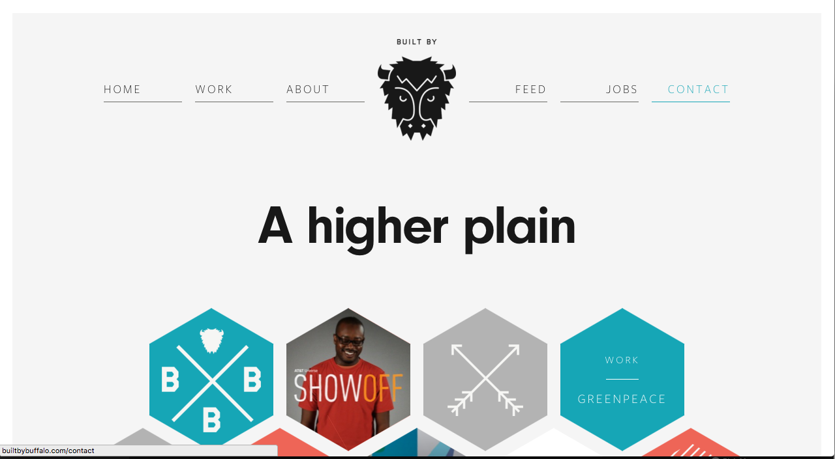

Built by Buffalo is a well-designed company that lets their client easily see the level of service they provide along with their skillsets.

The attitude you get from the website is the company are very laid back but with a great sense professionalism about them. This gives you the impression that communication with them will be easy and enjoyable but they will achieve the goals set out.

**Code 7[61]**

Code 7 is a website design and development agency located in Brighton. Like Built by Buffalo they were created in 2007 and have grown drastically since then. Ranking 1st in Google when searching for ‘website design and development in Brighton’.

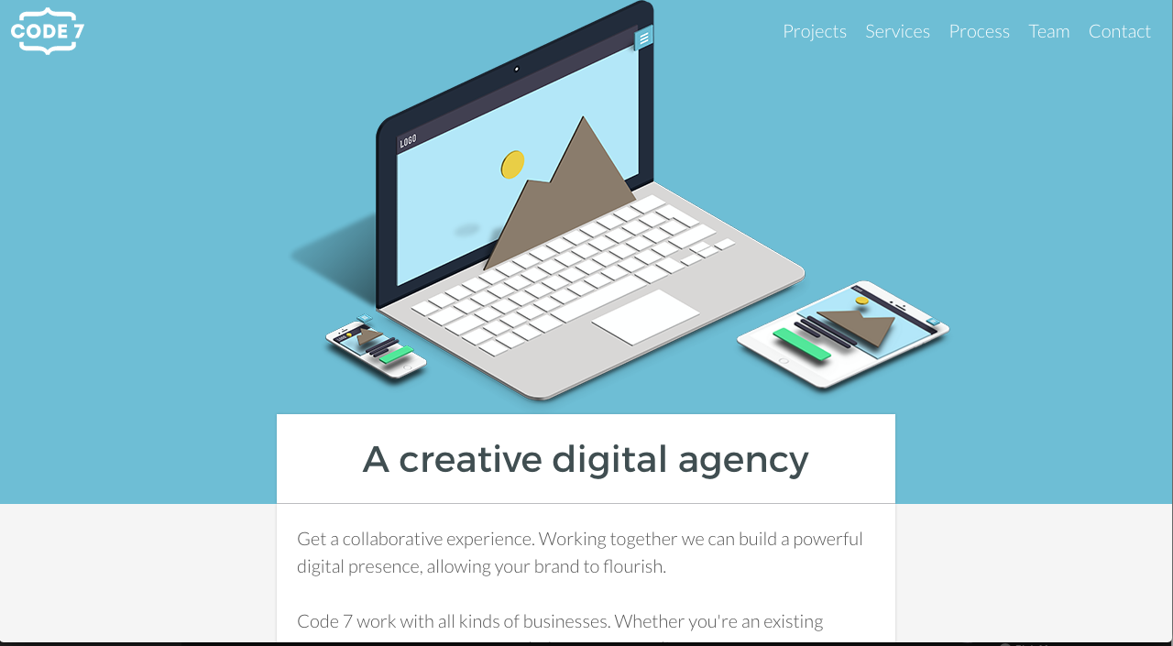

Code 7 are one of the leading website design & development agencies in Brighton & Hove. From the reviews I have seen on Google[62] Code 7 produce high quality work that satisfies their users needs. You can also see the impressive testimonials for specific projects on their website.[63] The design of their website does not appeal to me. However they have strong content, fairly good usability and enough respectable work in their portfolio to make them an extremely successful business.

Both Built by Buffalo and Code 7 are very respected digital design & development agencies In Brighton. They are direct competitors of one another in this sector and both advertise their company as creating great websites that are easy to use. When analysing these two agencies I could see they both had a very different approach; Built by Buffalo used a very clean and minimalistic style for their design and content. Code 7 used quite a busy design with lots of informative content throughout. Both have their advantages. Having a clean minimalistic design looks pleasant and allows the user to navigate through with ease. Having concise content means the user is more likely to contact Built by Buffalo regarding general questions, this will establish the first point of contact that could potentially turn into a lead through further communication. Having more informative content on the website can also be advantageous. The user contacting will be a stronger lead, as they would have learnt more about the business. This would result in their first point of contact being more qualitative, making them easier to convert into a lead.

To conclude, out of the two agency analysed my website will be more inspired by Built by Buffalo. This is because I will be looking to create a minimalistic design with subtle colours and a single deep accented colour. I will also be keeping the content concise like them. This is because I am going to be a new sole trader business with limited amount of portfolio work. So when a client contacts me regarding a question, I will have a better chance of converting them into a lead through communication.

I have created a table to show how I have rated these two design & development companies on a scale of 1 to 10. The results have been created from the information I gave in the competitor analysis and displayed in a table and radar graph.

|  |  |  |
| --- | --- | --- |
|  | **Built by buffalo** | **Code 7** |
| Quality of branding | 9 | 7 |
| Structure | 7 | 7 |
| Content | 6 | 7 |
| Landing page | 7 | 5 |
| Logo | 7 | 7 |

**Competitor analysis freelancers**

**Design Superheroes[64]**

Design Superheroes is a freelance ltd website design and development company located in Brighton & Hove. It is a highly ranked website on Google when searching for “Freelance designer & developer in Brighton”.

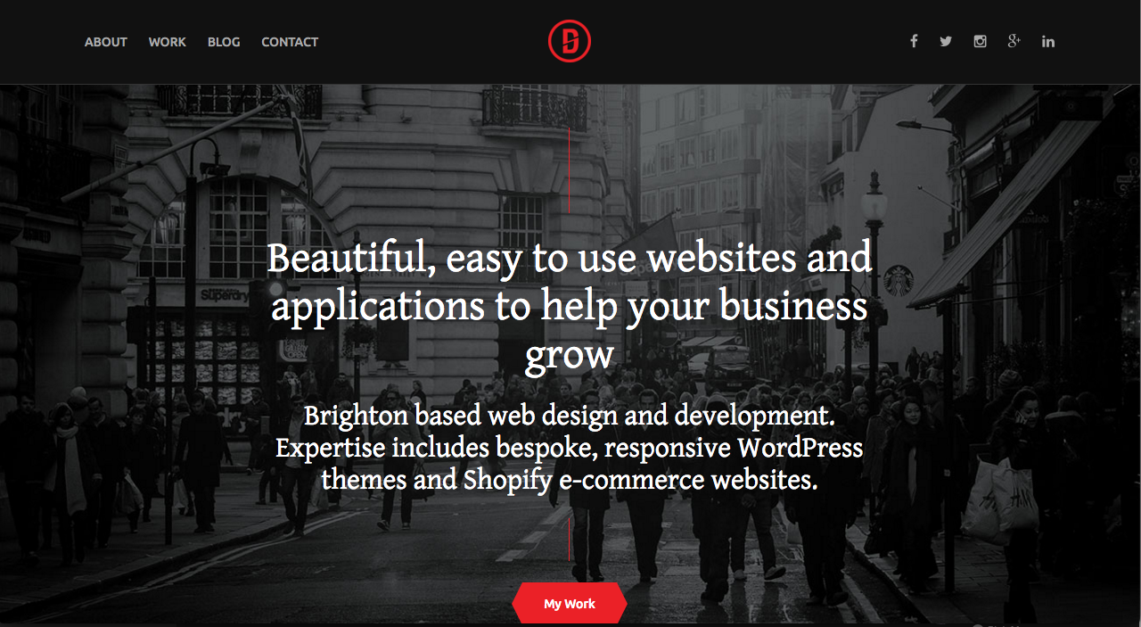

Design Superheroes is a great example of a freelance website done right. The design stands out whilst looking pleasant. The user experience allows for a great journey around the website. The development is clean and efficient and most importantly the branding and content is very personal. This really gives you the sense that working with this company will be an enjoyable experience.

**Roweena[65]**

Roweena is a freelance website design and development company is Brighton.

They rank 1st on Google when searching “Freelance website design development Brighton”.

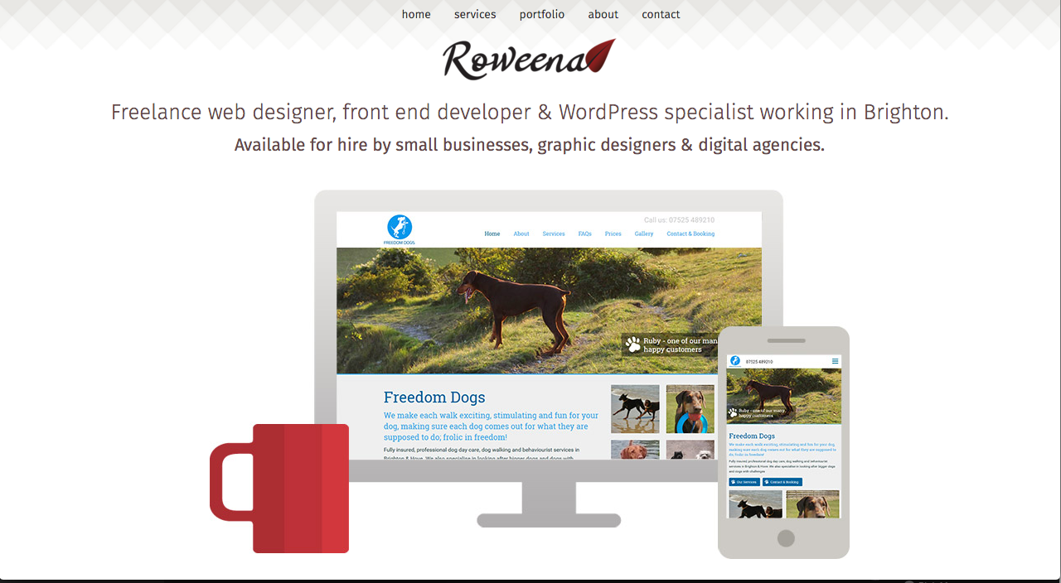

Roweena is a good freelance website that displays their content well. I personally dislike the design aspects of this website as I believe it is boring and lacks personality. The content is concise and explains what is needed, however it does not give away any personality of the individual or the company.

Both freelance companies have very different approaches to appeal to their target audience. Both structure their website different but individually very well. They each have concise content with very different messages being interpreted. Simple and minimalistic is the design they both strived for, however I felt Design Superheroes’ website flowed nicer and had a harder impact on me. In conclusion I learn a lot from analysing these two freelance companies. I gained a better understanding of how a minimalistic design can flow and stand out better than others. This is achieved by using 3-4 colours and making the copy, icons and buttons a vibrant colour compared to the simple coloured background. Making sure the structure of my website is easily accessible and the usability is simple and pleasant. This will be tested once my business website has a prototype to user test. One of the most important aspects I learnt from this analysis is the personalisation of a freelance website. After viewing Design Superheroes it influenced me to make my business website slightly more personalised. It will not have as much personal information as Design Superheroes, however it will have more than Roweenas. This is because Design Superheroes has a large portfolio of work, whereas I will not at the beginning stages of my business so will not want to take away from the professionalism of my company. When working with a client sometimes you want to show them a small insight into your personal life. This could allow potential customers, when browsing my website to get more familiar and accustom to my personality and values. Resulting in a client who would feel more comfortable contacting me as it attaches a real person to a website and brand.

From the information I have gained from this freelance individual competitor analysis, I will be able to rate the two freelance companies on a scale of 1 to 10. Below I have displayed the information gained in a table and radar graph.

|  |  |  |
| --- | --- | --- |
|  | **Design Superheroes** | **Roweena** |
| Quality of branding | 9 | 4 |
| Structure | 7 | 6 |
| Content | 9 | 7 |
| Landing page | 8 | 6 |
| Logo | 7 | 7 |

**Marketing activities**

*How to inform customers about the service/product you are offering and encourage them to buy it.*

Crank Creations business website will hold all of the information necessary for a client to be informed of our service and product. The SEO on the website will be optimised to help potential clients searching for a website designer be able to easily find the business website through Google. Using social media as a platform to market allows you to gain a lot more potential clients. Once a few projects have been created, those clients will market our service and product through word of mouth.

**External environment**

*What’s happening on a local, national or international level that is going to impact your business both positively and negatively.*

I have decided to create a PEST analysis diagram for my business. This is to understand the environmental factors I need to take into consideration for my business market. It is a useful strategic tool for understanding market growth or decline, business position, potential and direction for operations.[66]

|  |  |
| --- | --- |
| **Political**   * Government stability * Government policies * Future legalisations * Regulatory bodies and processes * War and conflict | **Economical**   * Inflation * Unemployment * Monetary issues * Increase/reduction in labour costs |
| **Social**   * Attitudes to work and leisure * Health and lifestyle * Social mobility * Clients attitudes and opinions * Change in demographic | **Technological**   * New technological discoveries * Rates of obsolescence * Rates of development * Licencing/ patents * Research showing new current web trends |

**Operations and risks**

*Think about exactly how you plan to run your business. What facilities and equipment will you need.*

In the early stages of my business I will need a computer/laptop and telephone as equipment to successfully run Crank Creations. I will be working from home and set up as a sole trader. As the business expands and evolves the amount of equipment needed will increase and my facility and legal status will change. I will be set up as a limited company and look to purchase an office space to work from. The equipment needed to run a business would be increased to compensate for the: change in workspace, increased number of staff, larger projects being worked on and evolutions in technology e.g. new computers.

**Me and my team**

*In order to run your business or progress with your idea, how many staff are you going to need?*

Initially all the company tasks will be undertaken by myself, however once the business begins to grow, staff will be employed to help manage the increasing number of projects. Those rolls consist of: managing the finance of the business, design work for projects, development for projects, marketing of the business and initial communications to source projects. In total a team of 4-6 would be ideal for the successful running of my business.

**Costs and income**

*1How much will it cost you to run your business on a: monthly, 6 monthly or yearly basis.*

I created a cash flow forecast and survival budget to accurately estimate my income and outgoings for the next 6 months. By creating this document I could plan in advanced for any shortage of money, to prepare myself if it were to happen. By rounding up your expenses and rounding down your income it can allow you to prepare for the worst-case scenario.

The difference between a cash flow forecast and a survival budget is a survival budget is focused on expenses for your personal life, for example: meals out, clothing and food shopping. A cash flow forecast focuses on the expenses that are compulsory for running a business, for example: living accommodation bills, rent and your mobile phone bill.

**Cash flow forecast & survival budget**

*The table below is a combination of a cash flow forecast and a survival budget.*

|  |  |  |  |  |  |  |  |
| --- | --- | --- | --- | --- | --- | --- | --- |
|  |  |  |  |  | **Month / 2016** |  |  |
|  |  |  |  |  |  |  |  |
|  |  | **March** | **April** | **May** | **June** | **July** | **August** |
| **Income** |  |  |  |  |  |  |  |
|  |  |  |  |  |  |  |  |
| Jamie’s Rent |  | £250.00 | £250.00 | £250.00 | £250.00 | £250.00 | £250.00 |
| Jemma’s Rent |  | £250.00 | £250.00 | £250.00 | £250.00 | £250.00 | £250.00 |
| Student finance |  |  | £2,900.00 |  |  |  |
| Web design/development work |  |  | £650 |  |  | £1,000.00 | £850 |
| **Total Income** |  | £500.00 | £4,050.00 | £500.00 | £500.00 | £1,500.00 | £1,350.00 |
|  |  |  |  |  |  |  |  |
| **Expenses** |  |  |  |  |  |  |  |
|  |  |  |  |  |  |  |  |
| Gas & Elec |  | £15.24 | £15.24 | £15.24 | £15.24 | £15.24 | £15.24 |
| Water |  | £6.34 | £6.34 | £6.34 | £6.34 | £6.34 | £6.34 |
| Broadband |  | £7.50 | £7.50 | £7.50 | £7.50 | £7.50 | £7.50 |
| Rent |  | £500.00 | £500.00 | £500.00 | £500.00 | £500.00 | £500.00 |
| Mobile phone |  | £15.00 | £15.00 | £15.00 | £15.00 | £15.00 | £15.00 |
| **Total Expenses** |  | £544.08 | £544.08 | £544.08 | £544.08 | £544.08 | £544.08 |
|  |  |  |  |  |  |  |  |
| **Survival budget** |  |  |  |  |  |  |  |
|  |  |  |  |  |  |  |  |
| Clothing |  | £30.00 | £30.00 | £30.00 | £30.00 | £30.00 | £30.00 |
| Food and housekeeping |  | £150.00 | £150.00 | £150.00 | £150.00 | £150.00 | £150.00 |
| Hire charges |  | £15.00 | £15.00 | £15.00 | £15.00 | £15.00 | £15.00 |
| Subscriptions |  | £22.50 | £22.50 | £22.50 | £22.50 | £22.50 | £22.50 |
| Entertainment (meals and drinks) |  | £100.00 | £100.00 | £100.00 | £100.00 | £100.00 | £100.00 |
| Children expenditure and presents |  | £20.00 | £20.00 | £20.00 | £20.00 | £20.00 | £20.00 |
| Travel |  | £50.00 | £50.00 | £50.00 | £50.00 | £50.00 | £50.00 |
| **Total Survival Expenses** |  | £679.08 | £679.08 | £679.08 | £679.08 | £679.08 | £679.08 |
|  |  |  |  |  |  |  |  |
|  |  |  |  |  |  |  |  |
| **Total Expenses + Total Survival Expenses** |  | £1,223.16 | £1,223.16 | £1,223.16 | £1,223.16 | £1,223.16 | £1,223.16 |
|  |  |  |  |  |  |  |  |
|  |  |  |  |  |  |  |  |
| **Net Cash Flow** |  | -£723.16 | £2,826.84 | -£723.16 | -£723.16 | £276.84 | £126.84 |
|  |  |  |  |  |  |  |  |
|  |  |  |  |  |  |  |  |
| **Monthly Opening Bank Balance** |  | £94.36 | -£628.80 | £2,198.04 | £1,474.88 | £751.72 | £1,028.56 |
|  |  |  |  |  |  |  |  |
|  |  |  |  |  |  |  |  |
| **Cash Position** |  | -£628.80 | £2,198.04 | £1,474.88 | £751.72 | £1,028.56 | £1,155.40 |

# 5. My company

## 5.1 Company name

**Majime studio**

When I was choosing a name for my company I wanted to have one that was unique and memorable. Majime is a Japanese term that signifies being responsible, reliable and getting things done without drama.[67] It is also an anagram of Jamie M. When searching domain names for my company I found that Majime studio was taken, along with: Majime design, Majime development and Majime. I wanted my company name to have an impact when first said to someone. I believed Majime studio had that impact. The main problem I found with Majime is how people would both pronounce it, and interpret how it’s spelt. This could be a large problem when explaining your business to someone and they return home realising they are unsure how to spell your company name.

**Crank design & development**

I decided to name my company “Crank”. I believe with the correct icon, typography and colour scheme this could work very nicely. A crank is most commonly known as a piece of equipment that fits between parts of a machine to create movement. The reason for choosing the word crank is because it represents my website design and development company. My company will act as the crank between the clients and the final product. It is a concise company name that will scale well. A key aspect of a company name, I believe, is to ensure the company can be represented with just the icon within the logo. It proves the design is eye catching and memorable.

**Crank Creations**

After creating the logo for Crank design & development I realised the name was too long and didn’t have the initial impact I wanted when explaining to someone. There were no ‘.co.uk’ or ‘.com’ domain names available for Crank design or Crank development (having Crank design & development was too hard to understand without spaces in the URL). I decided to change the company name to Crank creations. Crank creations is a lot easier to remember and understand, especially when written in a URL. I was able to purchase a ‘.co.uk’ and ‘.com’ domain name for crank creations. When explaining the company to individuals I believe Crank creations has a unique but relevant name linking the creations part to the deliverables getting produced.

## 5.2 Company logos

**Majime studio**

WRITE A BRIEF DESCRIPTION ABOUT IT AND THEN DO THE LIST OF LOGOS LIKE BELOW.

**Crank design & development**

When creating the logo for my website I wanted to use an icon that stood out to allow it to be used on it’s own. I wanted to use the word crank but also add design and development into that logo to show what the company does. I wanted to use the accented colour I will be using throughout my website. I wanted this colour to be a purple or blue. Blue represents creativity, imaginative and being wise. Purple represents trust, being dependable and strength.[68] All of these traits are what I want the user to feel when viewing my company website.

**Design 1**



After creating this logo I thought it was too text heavy and the icon was a small percentage of the logo. This needs to be a larger part so the website can be recognised with just the logo. I decided to use a cog as the icon because a crank fits onto a cog to and make it work. The cog represents the client’s project, when placed next to the company name ‘crank’ effectively shows how the company will make the client’s project work with design and development. I was experimenting with colours and thought I wanted my accent colour to be quite a dark purple or blue.

**Design 2**



I changed the design quite drastically. I increased the prominence of the icon and made the word ‘crank’ the main word to focus on. Giving design & development the same space as the single word crank. I really liked the typography used for the word, but the icon just didn’t stand out enough for me.

**Design 3**

****I decided to add common development icons into the large icon to give the company more relevance to website design and development. I also tightened up the spacing between the text and icons and switched the colour pallet around. I was still unhappy with the icon not thinking it stood out, especially if it was on it’s own.

**Design 4**



I improved the cog icon to fit closer with the website design and development settings style icon. I reduced the amount of accent colour to just the word ‘crank’.

**Design 5**



I decided to split the cog down the middle with colour. I believed this made the logo seem more design orientated. However I still was not quite happy with the colour scheme and how much the icon stood out. I began to test various colours using this design.





**Design 6**



I decided to split the cog in half and divide it slightly. I believe this made the icon stand out well and could be used alone to represent the company. I still was unsure about the accented colour but at this point I knew I wanted to keep black in the logo.

**Design 7**



I began to change the colours around to see what it would look like. I tried making the text saying ‘crank’ black but instantly thought against it after seeing this logo design. I felt like it should be the other bit of text in black and the accented colour for the word ‘crank’. I was very close to the logo I wanted.

**Design 8 – Final design**



I decided to go with a purple for my accented colour and keep the other colour black. I felt this gave it a slick design and made it very memorable and eye catching. This colour scheme will be used on my website, the black mainly for the text and the purple will be used as an accented colour throughout.

**Crank Creations**

Crank design & development, as a company name was too long. I decided to remove the ‘design & development and replace it with ‘creations’. I believe this had better flow and impact to allow people the remember it easier.

**Design 1**



I wanted to keep the design quite similar but with a few aspects updated. The font used for this logo is now updated to Campton. I removed it from all uppercase as it had quite a harsh/intrusive feel about it. I found this design would work for a website if the logo was left/right aligned on the website. The design I am looking for needs the logo to be center.

**Design 2**



This design was catered towards a logo that would sit in the center of a website navigation. It was designed to ensure the user recognised Crank is the dominating word in the name. However I found the word creations was too thin and small. This made the logo look disproportionate.

**Design 3**



I decided to increase the font weight and size to make the logo look more proportional. I found this design to have the largest impact whilst also retaining the clean look I was trying to achieve.

## 5.3 Company colour scheme

During the creation of the company logo I discovered that I wanted to use the colour blue or purple as the accented colour for my company. I decided to choose purple for the logo, however I still want to use blue within my company because studies show it represents creativity, being imaginative and wise[69]. Colours psychological meanings differ depending on the person but generally purple and blue represent trust and creativity. I created a colour palette to give myself a visual example of the colours that will represent my company, mainly on the website.



I will explain roughly where each colour in this palette will fit into the website (from left to right). Colour 1 will be used for subheadings. Colour 2 will be used as the accented colour for icons and occasional headings. Colour 3 will be used as the background colour. Colour 4 will be used occasionally for headings and as the footer background above the copyright information; this will be where contact information will sit and links to social media on each page. Colour 5 will be primarily used for body text, it will also be used as the copyright footer background.

The website will be very clean and minimalistic. Using a predominant amount of colour 3 with colour 1, 2 and 4 subtlety used throughout will do this. I believe this colour palette will make my company website look slick and modern. Whilst also being minimalistic and eye-catching. These are the main positive points I realised from the competitor analysis that I personally thought would make for a great website design.

## 5.4 Company layout ideas

The layout of a website is very important. You need to have the user in mind during the whole process. This is to ensure the website is user friendly. Making the website user friendly is one of the most important aspects in the design process. If a user cannot operate the website as intended, then you will potentially lose clients.

One of the main problems I encountered during the design stages was the lack of content I had to fill up each page. I had to cater my designs around the limited content.

All of the images/icons that were used in the design process are temporary (except the logo) and will be replaced with unique bespoke ones for development.

**Global Sections**

**Navigation**

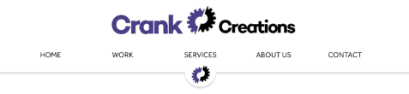

I wanted to have the navigation quite large when the user first landed on the page. This clearly allows the user to see how to navigate around the website. It also allows them to easily digest the company logo.

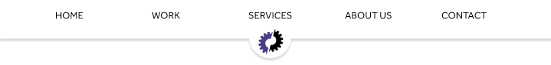

When the user starts to scroll down the page the full logo will get hidden. This is to prevent a large amount of the screen to be taken up whilst scrolling through the website. The navigation is fixed to the top of the screen but only with the short hand logo displaying below. The hide effect is done with JavaScript. It notices when the user has scrolled to a certain point on the screen and hides the full logo. When the user scrolls to the top of the page the full logo reappears.

**Footer**



The footer is located at the bottom of each page. It is the same on every page. The footer is used to display information such as: licencing, extra navigation, social media links, contact details and a call to action. I decided to add a small navigation at the bottom to allow users to access it faster after they have read the content of a page. The ‘Contact Us’ text is hyperlinked to the contact page, to entice the user to take the first steps in communication; this is the call to action. I have chosen to use a minimalistic footer to allow the user to focus on the text I intend them to read. By keeping the text minimal, it reduces the chance the user will intentionally not read it due to time constraints.

**Homepage**

**Full page**

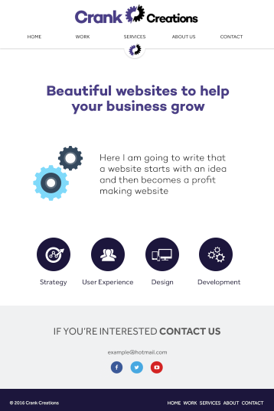

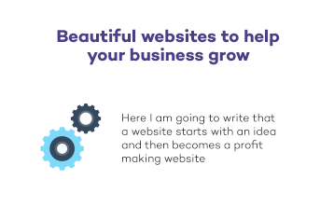

When the user first lands on the home page they initially see the title “Beautiful websites to help your business grow”. This instantly shows the user it is a website design and development company page. Below the title is an icon accompanied by a quote to show the user what they would be gaining from this service.



Just above the footer is a row of icons and headings showing the user the most important services we provide. These icons and headers are hyperlinked to take the user to the services page. When displayed on a mobile device the icons sit in a single file to make it easier to view on a small width screen.

**Work page**

**Add aspects from the work page**

**Services page**

**Full page**

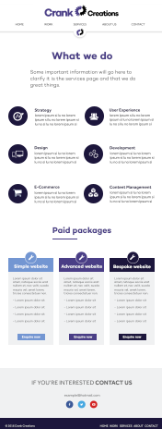

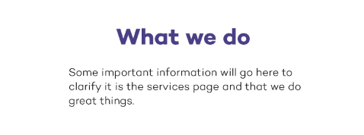

When the user lands on the services page the first bit of content they see will be a heading and sub-heading explaining what page they are on. This will allow the user to instantly understand what page they have navigated to and what they should expect to see if they continue on the page.

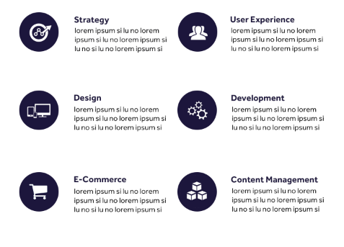

Below the title is the list of services we provide. Each service has a correlating icon and a brief description about it. When the user views the website on a mobile device it arranges the icons in a single column for easy viewing.

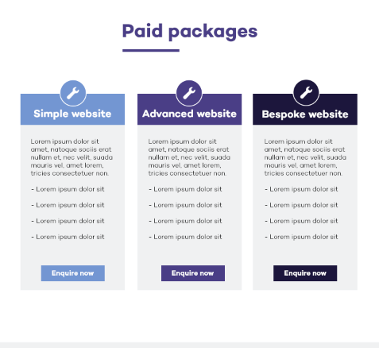

Below the list of services is a section displaying the packages a user is able to choose from. Those packages are: simple, advanced and bespoke. This gives the user a clear indication of the service they will receive, by seeing what package fits their desired website. Each package provides information to help the user select the right one. The ‘enquire now’ button will be added at a later stage. This will take the user to another page showing previously created websites from that specific package. This will help the user gain more of an understanding to what package is best suited for them.

**About page**

**Full page**

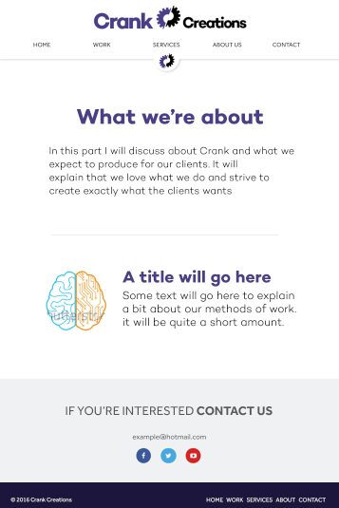

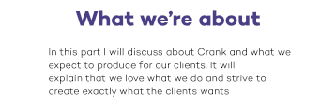

The title and sub-title on the ‘About’ page tells the user what page they have navigated to and gives a brief description about Crank as a company.

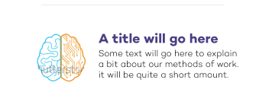

This section focuses on the company’s methods and what Crank deem as best practise in the industry. It is accompanied by a relevant image.

**Contact page**

**Full page**

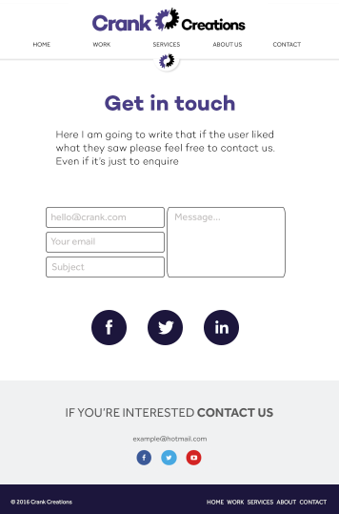

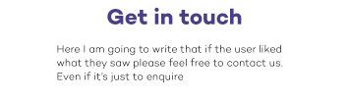

The title and sub-title of the contact page is to entice the user to contact us if they have any questions or if they would like to work with us.

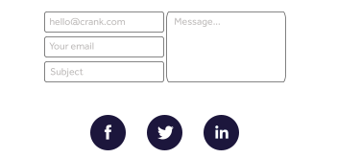

The main section on the contact page is the easy-to-use contact form that allows the user to enter their details and message into an online form that will automatically get sent to our company email. This is a process that makes it easier for the user to contact us. Below the easy-to-use contact form are icons linking to our social media websites.

## 5.5 Company assets

**Icons**

**WRITE A BREIF DESCRIPTION OF ALL OF THE ICONS I HAVE CREATED WITH A SCREENSHOT OF THEM ALL IN ILLUSTRATOR. THEN DO THE APPENDIX THING WITH THE REST.**

**ALSO LOOK TO CHANGE THE SCREENSHOTS**

**Strategy**

When creating a strategy for a project you must plan each operation well. If a task is poorly planned, it could potentially hinder future tasks that may depend on it. This reminded me of building blocks. If the foundation is poorly executed it will only cause trouble as the blocks stack higher.



**User experience**

The user experience of a website is how well the user interacts with it. For the icon I decided to create a three column wireframe of a website. This demonstrates a clean interface wireframe that would be easily accessible for users.



**Design**

The design of a website is everything visually displayed on it, such as: colour scheme, graphical designs and layout. When creating the icon for design I thought of a paper aeroplane. This is because everyone has his or her own favourite design for one. Some are more commonly known due to best practise, but when creating a paper aeroplane it really does come down to preference, like designing a website.



**Development**

The development of a website is the code used to produce everything seen on a website. I decided to make the icon for development be two brackets and a forward slash. This is a term very commonly used in HTML (the markup language used to display a website).



**E-commerce**

E-commerce (electronic commerce) means commercial transactions conducted electronically on the Internet. When creating an icon I chose to design a shopping cart. This is because it is a widely acknowledged icon to represent shopping, whether online or offline.



**Content management**

Content management is the way any content is organised. In terms of websites it means the storage (hosting) of the code and assets. This is most commonly done on a content management system. This is the reason I chose to use an abbreviation of the term content management system as my icon.



**Illustrations**

**DO A BRIEF DESCRIPTION OF ALL OF THE ILLUSTRATIONS/GIFS WITH A SCREEN SHOT OF THEM ALL. THEN DO THE APPENDIX THING FOR THEM ALL.**

**Homepage gif**

**Contact gif**

On the contact page for Crank Creations I produced a simple gif animation to make the page more exciting.

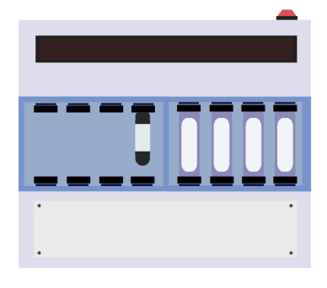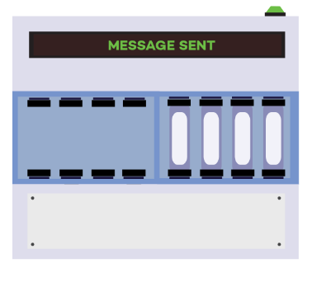

The image was created in Adobe Illustrator CC [70]. The image was created entirely of shapes.

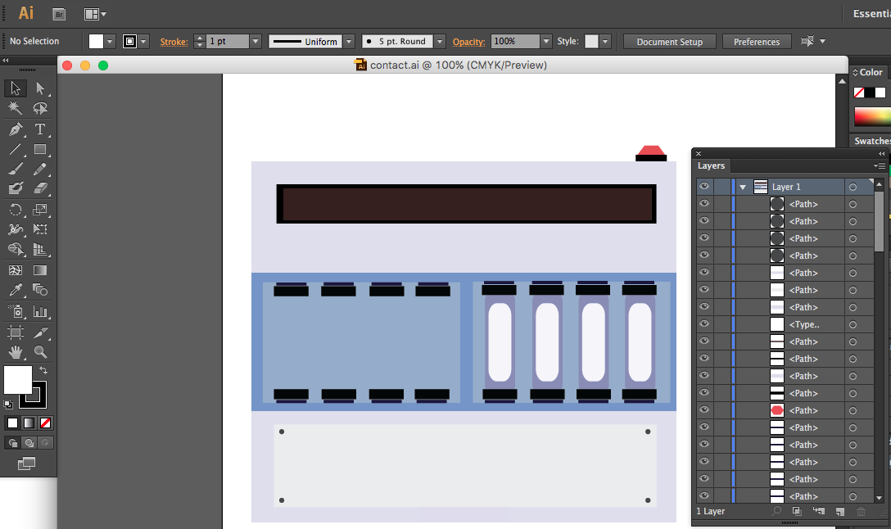

Once it was completed I then exported it into Adobe Photoshop CC [71]. Once it was exported into Photoshop I then began to create the Gif animation. The animation is 86kb in size and runs for approximately 7seconds. It is set to loop for continuous animation on the web page.

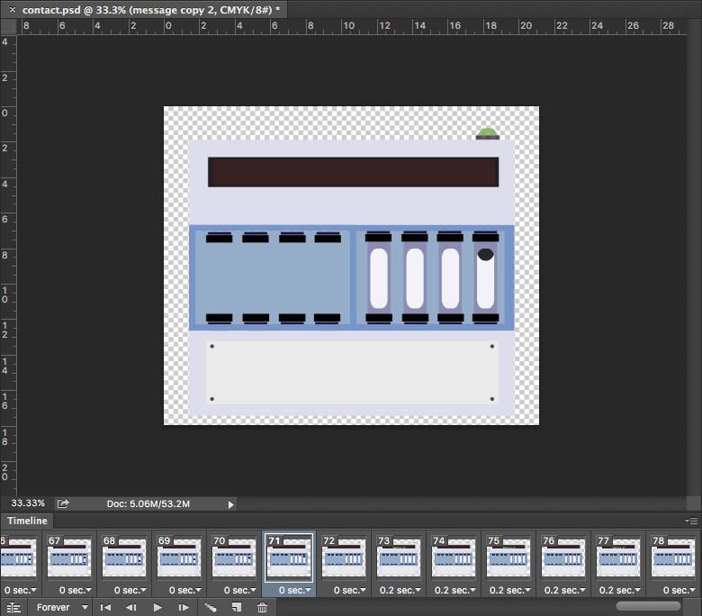

**Homepage**

**About**

**Work**

**Services (maybe)**

**Design and develop business cards**

## 5.6 Company fonts

**Heading and body font**



The font I used for the headings and body elements in the company website is called Campton. Campton is clean san-serif font that looks great in both bold or light font weight. For the heading elements Campton was used specifically in the bold format and for the body elements it was used in the light format. This was downloaded for free from the website font fabric[72]. I then made it into a web font through font squirrels web font generator[73]. Font squirrels web font generator is a service provided by font squirrel that allows users to convert a standard font format (.ttf, .otf, .eot etc.) into a web font. This allows standard fonts to be used in the development of websites by creating a HTML and CSS file for them, that you copy into your code. Certain fonts are blacklisted from this service, so you must make sure the font is allowed to be used for web before converting.

**Font stack**

When using a downloaded font it is very important to have fall-back web safe fonts in case the users browser is unable to render/use the font. This process is called a font stack. For example if the HTTP request for the font file times out, it will corrupt the font, rendering it useless at that time. This is why having web safe fonts as a fall-back is important to ensure all users have a similar experience on the website.

**ONCE THE OTHER FONTS HAVE BEEN CHOSEN I WILL WRITE ABOUT TESTING ALL OF THE FONTS ACROSS DIFFERENT BROWSERS AND DEVICES.**

**TECHNICAL GRASP**

**UNDERSTANDING OF PROBLEM AREA**

**PROJECT MANAGEMENT**

**REPORT QUALITY**

**EVIDENCE OF LEARNING**

**RESEARCH EFFORT**

**PROJECT EXHIBITION (10%)**

|  |  |  |  |  |  |  |  |
| --- | --- | --- | --- | --- | --- | --- | --- |
| **Grade** | **Technical grasp** | **Understanding of problem area** | **Project management** | **Report quality** | **Evidence of learning** | **Research effort** | **Project Exhibition (10%)** |
| **A+ 80-100%** | Outstanding technical understanding, exploration and insight | Original approach, execution and performance | Outstanding professional level of project management with all stages /changes thoroughly documented | Outstanding organisation , structure and standard of presentation | Evidence of very high quality analysis, synthesis, evaluation and critical evaluation | Evidence of intellectual rigour, independence of judgement and insightful contextualisation | Inspirational, innovative and authoritative |
| **A >70%** | Excellent technical insight demonstrated to a professional level | Showed professional level of insight into the whole area in which the project is embedded | Completely successful and entirely self-managed | Excellent – clear, substantial, fluent, correctly organised, convincing and with no omissions | Mature reflection on the whole process, showing professional level of insight | Competent and thorough coverage of the field with excellent research in many areas. Research clearly influenced outcomes | Excellent – clear, substantial, fluent, convincing, with a poster exemplifying these qualities |
| **B 60-70%** | Good technical insight in nearly all areas | Showed a wide understanding of the problem area – few questionable aspects | Good planning, self-motivation and control of activities | Clear, thorough and convincing in almost all respects | Convincing evidence of learning across several different aspects of project activity | Competent and thorough coverage, with excellent research in some areas, clearly influenced outcomes | Clear, thorough and convincing in almost all respects |
| **C 50-60%** | About normal technical grasp for a Level 3 student | Adequate overall, but some significant aspects of the problem space were not fully appreciated | Adequate planning self-motivation and control of most activities – some lapses | Substantially satisfactory, but with some sections weak or missing | Evidence of some learning, normally in more than one aspect of project activity | Fairly thorough and mainly convincing research effort, some evidence of research influencing the outcome | Substantially satisfactory, but with some explanations weak or missing |
| **D 40- 50%**  **PASS** | Below typical for Level 3 – some weak aspects | Shows a largely immature, narrow or distorted view of the setting in which the product sits | Student required a substantial amount of management or guidance | Disappointing overall, with only about half the areas adequately treated | Only limited evidence of having learnt to do anything differently next time | Some evidence of research, though the connection between research and other outcomes is limited | Disappointing overall, with largely inadequate explanation and no or poor poster |
| **E <40%**  **REFER** | Weak in many respects - below pass standard, but not completely irretrievable | Weak in most respects, but student shows some understanding and could improve | Could not function without external control | Weak in most respects, below pass standard, but could be improved | Little evidence student has benefited from the experience; additional learning and reflection required | *Either* little relevant research *or* little connection between research and other outcomes | Weak in most respects, below pass standard, but could be improved |
| **F <30%**  **FAIL** | Completely unsatisfactory | Completely unsatisfactory | Completely unsatisfactory | Completely unsatisfactory | No evidence that the student has benefited | No evidence of research | Completely unsatisfactory |

**The bibliography should be organised alphabetically, by author’s last name. You should really use a standard referencing style (such as Harvard) – there are online tool s to help generate references.**

**e.g.**

**Siltala, M., 2013. Title. URL. Date accessed.**

**Strategyzer, 2015. Title. Etc.**

# 6. Bibliography

Siltala, M. (2013). *Color Emotion Guide.* Available: http://visual.ly/color-emotion-guide. Last accessed 29th Nov 2015.

Strategyzer. (2015). *The Business Model Canvas.* Available: http://www.businessmodelgeneration.com/canvas/bmc. Last accessed 23rd November 2015.

Ciotti, G. (2013). *The Psychology of Color in Marketing and Branding.* Available: http://www.helpscout.net/blog/psychology-of-color/. Last accessed 30thv November 2015.

Sass. (2006). *CSS with superpowers.* Available: http://sass-lang.com/. Last accessed 4th Dec 2015.

Coyier, C. (2012). *Poll Results: Popularity of CSS Preprocessors.*Available: https://css-tricks.com/poll-results-popularity-of-css-preprocessors/. Last accessed 4th Dec 2015.

Way, J. (2011). *Should You Learn CoffeeScript?.* Available: http://code.tutsplus.com/articles/should-you-learn-coffeescript--net-23206. Last accessed 7th Dec 2015.

Top 15 Most Popular Social Networking Sites. (2015). *Top 15 Most Popular Social Networking.* Available: <http://www.ebizmba.com/articles/social-networking-websites>. Last accessed 11th December 2015

Nutella. (2013). *Nutella.* Available: https://www.facebook.com/nutellauk/?brand_redir=24932281961. Last accessed 11th Dec 2015.

Sornoso, E. (2014). *9 Small Business Twitter Marketing Examples to Study.* Available: http://www.socialmediaexaminer.com/small-businesses-twitter-marketing/. Last accessed 14th Dec 2015.

Ten 4. (2015). *WHAT WE DO.* Available: http://www.ten4design.co.uk/info. Last accessed 16th Dec 2015.

Krieg, E. (2015). *pure JavaScript vs. jQuery.* Available: https://teamtreehouse.com/community/pure-javascript-vs-jquery-2. Last accessed 20th Dec 2015.

Font fabric. (2014). *Campton free font.* Available: http://www.fontfabric.com/campton-free-font/. Last accessed 7th January 2016.

Font squirrel. (2015). *Webfont generator.* Available: http://www.fontsquirrel.com/tools/webfont-generator. Last accessed 7th January 2016.

Wipo. (2016). *What is Intellectual Property?.* Available: http://www.wipo.int/about-ip/en/. Last accessed 26th Jan 2016.

Chmielewski, T. (2016). *What Happens If Someone Breaks a Copyright Law?.* Available: http://smallbusiness.chron.com/happens-someone-breaks-copyright-law-55834.html. Last accessed 26th Jan 2016.

legislation.gov.uk. (). *Copyright, Designs and Patents Act 1988.*Available: http://www.legislation.gov.uk/ukpga/1988/48/contents. Last accessed 26th Jan 2016.

Simpson, M. (2013). *What is Professional Indemnity Insurance.*Available: https://www.know-insurance.co.uk/business/what-professional-indemnity-insurance. Last accessed 26th Jan 2016.

Investopedia. (2016). *Property Insurance.* Available: http://www.investopedia.com/terms/p/property-insurance.asp. Last accessed 26th Jan 2016.

W3C. (2012). *Web Content Accessibility Guidelines (WCAG) Overview.*Available: https://www.w3.org/WAI/intro/wcag.php. Last accessed 29th Jan 2015.

Wikipedia. (2016). *User agent.* Available: https://en.wikipedia.org/wiki/User_agent. Last accessed 30th November 2015.

Baseel, C. (2014). *Eight Japanese words we’d love to import into English.* Available: http://en.rocketnews24.com/2014/04/08/eight-japanese-words-wed-love-to-import-into-english/. Last accessed 4th Feb 2016.

Drewniak, J. (2015). *Creating Your Own CSS Grid System.* Available: http://j4n.co/blog/Creating-your-own-css-grid-system. Last accessed 10th Feb 2016.

Gallagher, N. (2016). *normalize.css.* Available: http://necolas.github.io/normalize.css/. Last accessed 11th Feb 2016.

Gallagher, N. (2012). *About normalize.css.* Available: http://nicolasgallagher.com/about-normalize-css/. Last accessed 11th Feb 2016.

Gov.uk. (2015). *Sole trader.* Available: https://www.gov.uk/business-legal-structures/sole-trader. Last accessed 8th March 2016.

Gov.uk. (2015). *Limited company.* Available: https://www.gov.uk/business-legal-structures/limited-company. Last accessed 8th March 2016.

Wired Sussex. (2016). *Get wired today.* Available: http://www.wiredsussex.com/members/. Last accessed 8th March 2016.

Griffiths, C & Crescenzo, B (2013). *My Start-up Plan*. 2nd ed. Hampshire: Harriman house LTD. p1-25.

Berry, T. (2009). *What is a Business Plan?.* Available: http://articles.bplans.co.uk/writing-a-business-plan/what-is-a-business-plan/384. Last accessed 8th March 2016.

Chapman, A. (1999-2015). *pest market analysis tool.* Available: http://www.businessballs.com/pestanalysisfreetemplate.htm. Last accessed 10th Nov 2015.

Sapsed, J & Nightingale, P. (2013). *The Brighton Fuse.* Available: http://www.brightonfuse.com/wp-content/uploads/2013/10/The-Brighton-Fuse-Final-Report.pdf. Last accessed 10th Nov 2015.

Wired Sussex. 2013. *Findings from The Brighton Fuse Report.* [online]. [10th Nov 2015]. Available at: <https://www.youtube.com/watch?v=GgFl_R_sANw>

University of Sussex. (2015). *Brighton Fuse 2 Project: The Role of Freelancers in the Brighton’s Creative Digital IT Cluster.* Available: http://www.sussex.ac.uk/spru/research/tim/timresearch/brightonfuse2. Last accessed 10th Nov 2015.

Sapsed, J. (2015). *Brighton Fuse 2: Freelancers in the Creative Digital IT Economy.* Available: http://www.brightonfuse.com/wp-content/uploads/2015/01/brighton_fuse2_online.pdf. Last accessed 10th Nov 2015.

LaunchSpark Video. 2013. *What is The Lean Startup?.* [Online]. [11th November 2015]. Available from: <https://www.youtube.com/watch?v=_a3s0IXSuxY>.

Ries, E. (2011). *The Lean Startup*. USA: Crown Business (USA). p1-336.

**Next Stages**

1. INTRODUCTION

3.2 CREATE TABLE TO SHOW TOOLS USED

3.4 ADD A CONTRACT EXAMPLE

3.4 ADD AN INVOICE EXAMPLE

3.7 WRITE WHAT INSURANCE I AM GOING TO USE

5.2 ADD MAJIME STUDIO LOGOS

5.4 ADD A WORK PAGE SECTION

5.5 DESIGN OWN ICONS

5.5 DESIGN AND DEVELOP BUSINESS CARDS

5.5 FINISH LIST OF FONTS (IF ANYMORE) AND WHEN DONE TEST ACROSS DIFFERENT DEVICES AND BROWSERS

**Everything else I need to do**

* **INTRODUCTION** – what the project is and what are the aims. TELLING THEM WHAT THEY ARE MARKING AND HOW TO MARK IT. Mention that I am doing a website for speak the speech.
* **EVALUATION** – evaluation of the product (website) and project (did it meet its aims, what needs to still be done, etc)
* **DESIGN STAGE** in the appendix and keep the main design section a summary of each change that was made. So keep final design logos of each in there. Do the same with the user tests, just keep the results/evaluation in the main report and the rest in the appendix. Do a design appendix, user test appendix etc.
* I need to mention about all of the last points in the report (bits from student central) in my evaluation e.g. talk about the technical grasp of this project.
* Go through and trim the whole report. MAKE IT ACCESSILBE FOR THE READER .
* PUT MY WEBSITE (and client) URL AT THE BOTTOM OF THE TABLE OF CONTENT so it is easy to see.
* PUT EVERYTHING THAT IS CITED INTO THE BIBLIOGRAPHY. Code7 website etc.

1. http://www.brightonfuse.com/
2. http://www.wiredsussex.com/
3. https://www.brighton.ac.uk/index.aspx
4. http://www.sussex.ac.uk/
5. http://www.ncub.co.uk/
6. Sapsed, J & Nightingale, P. (2013). *The Brighton Fuse.* Available: http://www.brightonfuse.com/wp-content/uploads/2013/10/The-Brighton-Fuse-Final-Report.pdf. Last accessed 10th Nov 2015.
7. Wired Sussex. 2013. *Findings from The Brighton Fuse Report.* [online]. [10th Nov 2015]. Available at: https://www.youtube.com/watch?v=GgFl_R_sANw
8. University of Sussex. (2015). *Brighton Fuse 2 Project: The Role of Freelancers in the Brighton’s Creative Digital IT Cluster.* Available: http://www.sussex.ac.uk/spru/research/tim/timresearch/brightonfuse2. Last accessed 10th Nov 2015.
9. Sapsed, J. (2015). *Brighton Fuse 2: Freelancers in the Creative Digital IT Economy.* Available: http://www.brightonfuse.com/wp-content/uploads/2015/01/brighton_fuse2_online.pdf. Last accessed 10th Nov 2015.
10. LaunchSpark Video. 2013. *What is The Lean Startup?.* [Online]. [11th November 2015]. Available from: https://www.youtube.com/watch?v=_a3s0IXSuxY.
11. Eric Ries (2011). *The Lean Startup*. USA: Crown Business (USA). p1-336.
12. http://builtbybuffalo.com/
13. http://foundation.zurb.com/
14. Clearleft. (2016). *We design compelling digital experiences..* Available: http://clearleft.com/. Last accessed 22nd Jan 2016.
15. http://clearleft.com/thinks/118
16. Ten 4. (2015). *WHAT WE DO.* Available: http://www.ten4design.co.uk/info. Last accessed 16th Dec 2015.

   
17. https://github.com/ten4design/ten4-framework
18. https://craftcms.com/
19. http://www.slimframework.com/
20. http://blog.getbootstrap.com/2015/08/19/bootstrap-4-alpha/
21. http://www.sublimetext.com/
22. http://brackets.io/
23. https://modernizr.com/
24. https://necolas.github.io/normalize.css/
25. http://sass-lang.com/
26. http://lesscss.org/
27. http://coffeescript.org/
28. https://git-scm.com/
29. https://subversion.apache.org/
30. Sass. (2006). *CSS with superpowers.* Available: http://sass-lang.com/. Last accessed 4th Dec 2015.
31. Chris Coyier. (2012). *Poll Results: Popularity of CSS Preprocessors.*Available: https://css-tricks.com/poll-results-popularity-of-css-preprocessors/. Last accessed 4th Dec 2015.
32. http://gulpjs.com/
33. http://960.gs/
34. http://fluidable.com/
35. http://onepcssgrid.mattimling.com/
36. Drewniak, J. (2015). *Creating Your Own CSS Grid System.* Available: http://j4n.co/blog/Creating-your-own-css-grid-system. Last accessed 10th Feb 2016.
37. Jeffrey Way. (2011). *Should You Learn CoffeeScript?.* Available: http://code.tutsplus.com/articles/should-you-learn-coffeescript--net-23206. Last accessed 7th December 2015.
38. Gallagher, N. (2016). *normalize.css.* Available: http://necolas.github.io/normalize.css/. Last accessed 11th Feb 2016.
39. Gallagher, N. (2012). *About normalize.css.* Available: http://nicolasgallagher.com/about-normalize-css/. Last accessed 11th Feb 2016.
40. Erik Krieg. (2015). *pure JavaScript vs. jQuery.* Available: https://teamtreehouse.com/community/pure-javascript-vs-jquery-2. Last accessed 20th Dec 2015.
41. http://patternlab.io/
42. Top 15 Most Popular Social Networking Sites. (2015). *Top 15 Most Popular Social Networking.* Available: <http://www.ebizmba.com/articles/social-networking-websites>. Last accessed 11th Dec 2015
43. Nutella. (2013). *Nutella.* Available: https://www.facebook.com/nutellauk/?brand_redir=24932281961. Last accessed 11th Dec 2015.
44. Top 15 Most Popular Social Networking Sites. (2015). *Top 15 Most Popular Social Networking.* Available: <http://www.ebizmba.com/articles/social-networking-websites>. Last accessed 11th Dec 2015
45. Eric Sornoso. (2014). *9 Small Business Twitter Marketing Examples to Study.* Available: http://www.socialmediaexaminer.com/small-businesses-twitter-marketing/. Last accessed 14th Dec 2015.
46. Top 15 Most Popular Social Networking Sites. (2015). *Top 15 Most Popular Social Networking.* Available: <http://www.ebizmba.com/articles/social-networking-websites>. Last accessed 14th Dec 2015
47. Strategyzer. (2015). *The Business Model Canvas.* Available: http://www.businessmodelgeneration.com/canvas/bmc. Last accessed 23rd November 2015.
48. Gov.uk. (2015). *Sole trader.* Available: https://www.gov.uk/business-legal-structures/sole-trader. Last accessed 8th March 2016.
49. Gov.uk. (2015). *Limited company.* Available: https://www.gov.uk/business-legal-structures/limited-company. Last accessed 8th March 2016.
50. Wired Sussex. (2016). *Get wired today.* Available: http://www.wiredsussex.com/members/. Last accessed 8th March 2016.
51. Simpson, M. (2013). *What is Professional Indemnity Insurance.*Available: https://www.know-insurance.co.uk/business/what-professional-indemnity-insurance. Last accessed 26th Jan 2016.
52. Investopedia. (2016). *Property Insurance.* Available: http://www.investopedia.com/terms/p/property-insurance.asp. Last accessed 26th Jan 2016.
53. Wipo. (2016). *What is Intellectual Property?.* Available: http://www.wipo.int/about-ip/en/. Last accessed 26th Jan 2016.
54. Chmielewski, T. (2016). *What Happens If Someone Breaks a Copyright Law?.* Available: http://smallbusiness.chron.com/happens-someone-breaks-copyright-law-55834.html. Last accessed 26th Jan 2016.
55. legislation.gov.uk. (). *Copyright, Designs and Patents Act 1988.*Available: http://www.legislation.gov.uk/ukpga/1988/48/contents. Last accessed 26th Jan 2016.
56. W3C. (2012). *Web Content Accessibility Guidelines (WCAG) Overview.*Available: https://www.w3.org/WAI/intro/wcag.php. Last accessed 29th Jan 2015.
57. Wikipedia. (2016). *User agent.* Available: https://en.wikipedia.org/wiki/User_agent. Last accessed 30th November 2015.
58. Berry, T. (2009). *What is a Business Plan?.* Available: http://articles.bplans.co.uk/writing-a-business-plan/what-is-a-business-plan/384. Last accessed 8th March 2016.
59. Griffiths, C & Crescenzo, B (2013). *My Start-up Plan*. 2nd ed. Hampshire: Harriman house LTD. p1-25.
60. http://builtbybuffalo.com/
61. http://www.code7.co.uk/
62. Bushell, C et al.. (2014-2015). *Code 7 Reviews.* Available: https://www.google.co.uk/search?q=code+7+reviews&ie=utf-8&oe=utf-8&gws_rd=cr&ei=FaJAVu1Hga5SjIyVsAY#gws_rd=cr&lrd=0x4875855ba68e09a9:0xece3bbded965e414,1. Last accessed 9th Nov 2015.
63. http://www.code7.co.uk/projects/
64. <http://designsuper.co/>
65. http://www.roweena.co.uk/
66. Chapman, A. (1999-2015). *pest market analysis tool.* Available: http://www.businessballs.com/pestanalysisfreetemplate.htm. Last accessed 10th Nov 2015.
67. Baseel, C. (2014). *Eight Japanese words we’d love to import into English.* Available: http://en.rocketnews24.com/2014/04/08/eight-japanese-words-wed-love-to-import-into-english/. Last accessed 4th Feb 2016.
68. Matt Siltala. (2013). *Color Emotion Guide.* Available: http://visual.ly/color-emotion-guide. Last accessed 29th Nov 2015.
69. Gregory Ciotti . (2013). *The Psychology of Color in Marketing and Branding.* Available: http://www.helpscout.net/blog/psychology-of-color/. Last accessed 30th November 2015.
70. http://www.adobe.com/uk/products/illustrator.html
71. http://www.adobe.com/uk/products/photoshop.html
72. Font fabric. (2014). *Campton free font.* Available: http://www.fontfabric.com/campton-free-font/. Last accessed 7th January 2016.
73. Font squirrel. (2015). *Webfont generator.* Available: http://www.fontsquirrel.com/tools/webfont-generator. Last accessed 7th January 2016.